Chase Lester

NBA Write UP

Question #3: What does the Win/Loss record tell us about an organization’s regular season success? Is one conference stronger than another? Do teams have a home field advantage?

**Number of Winning Seasons in last 10 years**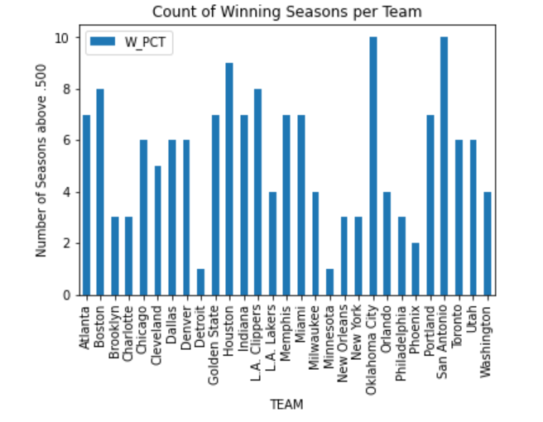

From 2010-2019 NBA teams have had varying degrees of success. Some are consistently good while others tend to be bad from year to year. Others find varying degrees of success. Teams such as Houston, Golden State, Boston, San Antonio, and the Clippers have 7 or more seasons over .500 out of the last 10. Those make up the most successful regular season teams. Minnesota, Phoenix, Detroit, and Sacramento make up the bottom of the barrel with 2 winning seasons or less. There are many more teams in the middle of the pack hence average teams. These are Cleveland, Washington, Lakers, and Dallas to name a few.

**Team Win Percentages**

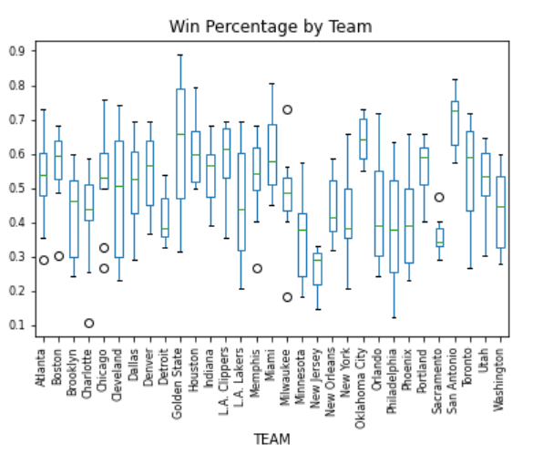A lot of the teams show little variation in their win percentages from season to season. Most teams tend to perform near the same level each year. Some teams acquire key players through the draft, free agency, or trade. This can lead a team to perform above their norm or below it. Losing a key piece will hurt a franchise. The two teams with the greatest range are Golden State and Philadelphia. Golden State has mostly been a successful team and had an absurd win rate setting the record for highest win percentage in a season, but they also had a season that performed way below that standard where they finished below .500. Philadelphia is on the opposite end of the spectrum. They have been a team that has performed way below .500 with their highest percentage coming in just above .600 and their lowest being barely of .100. A majority of the outlier seasons have been NBA teams' worst seasons. Only two teams Milwaukee and Sacramento have a season each that performed way above their normal expectation.

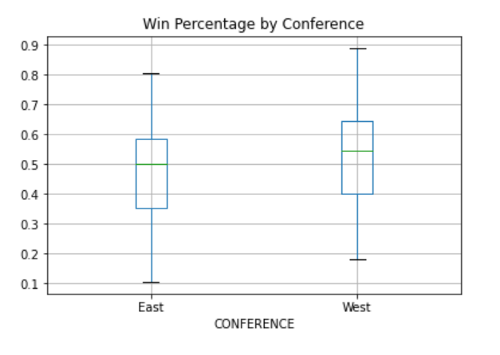**Conference Win Percentages**

From 2010-2019 the West has performed better on average compared to the East. The West conference boasts a 52% win rate whereas the East has a 48% win rate. In addition, a team on average earns 42 wins in the West compared to 38 in the East. During the regular season, the West performs better overall compared to the East.

**Home vs. Road Wins**

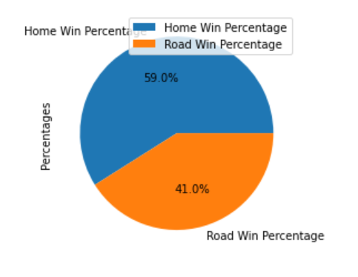

Home field advantage does exist in the NBA. The home team boasts a 59% win percentage compared to the 41% of road teams who win. In addition, the West is better at home than the East with a 62% win rate compared to a 56%.